Contact Information: FOR IMMEDIATE RELEASE
Sheila Lyons/Emma Andelson
executivedirector@apollochorus.org
pr@apollochorus.org
(312) 427-5620

Stephen Alltop, Music Director & Conductor
Announces the
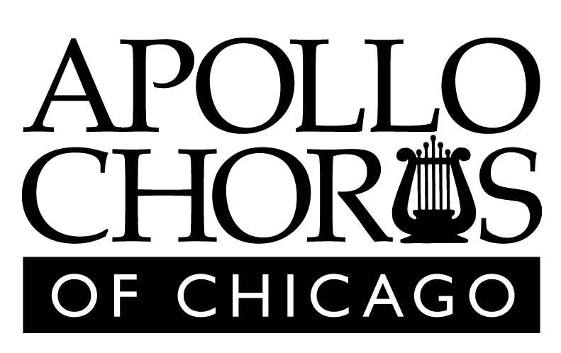
CARMINA BURANA AND MIDWESTERN MASTERS

Chicago, Ill. — One of the most renowned musical organizations in the nation, The Apollo Chorus of Chicago, is celebrating 146 years of making music this year with a 2017-2018 season featuring an exhilarating lineup of choral blockbusters. The Apollo Chorus presents Orff’s Carmina Burana and Midwestern Masters as its Spring Concert and season finale with two performances on Friday, May 4 at 7:30 p.m. at Fourth Presbyterian Church, 126 E. Chestnut St.; and Sunday, May 6, 2017 at 3:00 p.m. at First United Church, 848 Lake St., Oak Park.

One of the most epic choral works of all time, Carmina Burana explores themes as familiar today as they were in the 13th century: fickleness of fortune and wealth, the joy of the return of Spring, and the pleasures and perils of drinking, gluttony and lust. Joined with delightful pieces by some of the Midwest’s greatest composers, this concert is not to be missed! In addition to Orff’s masterpiece, the Apollo Chorus will present choral works by esteemed Midwestern composers, including Stacy Garrop, Jeremy Beck, and Stephen Paulus.

Praised for her “warmth” and “radiant vocal ease,” soprano Véronique Filloux looks forward to spending her summer as a Bonfils-Stanton Foundation Studio Artist with Central City Opera, where she will sing Papagena (Die Zauberflöte). She recently completed a summer with Opera NEO, singing Isifile (Il Giasone) and covering Despina (Così fan tutte). A proud member of the Maryland Opera Studio, she made her company debut in the 2016-2017 season, originating the role of Lily (The Young King) and covering both Amore (Orfeo ed Euridice) and Lucia (The Rape of Lucretia). She sings Servilia (La clemenza di Tito) and Soeur Constance (Dialogues des Carmélites) in their current season and will graduate with her Master of Music this spring. Past roles include Adele (Die Fledermaus), Olympia (Les contes d’Hoffmann), and Silberklang (The Impresario). Passionate about concert work, Filloux has sung the soprano solos in Poulenc’s Gloria, Handel’s Messiah, Gordon/Lang/Wolfe's lost objects, and several Bach cantatas. She is thrilled to be performing the soprano solo in Orff's Carmina Burana with the Apollo Chorus of Chicago.

Tenor Justin Berkowitz has been praised for his "exacting and animating" performances, and has gained much attention for his character work, as well as clear, bel canto singing. His 2017-18 season has been marked with several exciting debuts, including Monostatos in The Magic Flute with Opera Louisiane and Phantase in Ariane et Bachus with Haymarket Opera, Dr. Caius in Falstaff with Opera on the James and a return to St. Petersburg Opera where he sang Jack in Into The Woods. During the fall, he also made his debut with the Chicago Philharmonic performing the tenor solo in Carmina Burana. Previous engagements include performances with Central City Opera, Opera Naples, Chicago Opera Theater, DuPage Opera Theater, St. Petersburg Opera, Ohio Light Opera, among others. Known for his interpretation of Orff’s tenor solo in Carmina Burana, Justin has performed the piece throughout the country including engagements with the Northwestern University Summer Concerts, Annapolis Choral Society, Windy City Chorus, University of Michigan, Michigan Glee Clubs, Osh Kosh Symphony and Dudley Birder Chorale, among others. Upcoming engagements include performances with the Mobile Symphony. Justin received degrees from Lawrence University and Conservatory and the University of Michigan.

Baritone Josh Quinn has been praised for his “butter-smooth timbral beauty” (Boston Musical Intelligencer) and for vocalism to which one should “sit up and take listen” (Dallas News). As a Gerdine Young Artist at the Opera Theatre of Saint Louis, he sang the roles of the 2nd Commissioner in Dialogues of the Carmelites and Rabonnier in La Rondine, and covered the Marquis in Dialogues of the Carmelites, Leo Stein in the world premiere of Ricky Ian Gordon’s “27,” Rambaldo in La Rondine, and Isacio in the US premiere of Handel’s Richard the Lionheart. Highlights of Quinn’s recent seasons include Sciarrone in Tosca at Maine’s PORTopera; Jesus in the St. Matthew’s Passion with the New York Metamorphosis Orchestra; his debut with the American Symphony Orchestra in Hindemith’s opera The Long Christmas Dinner; and Don Alfonso in Così fan tutte with the Merola Opera Program. In 2017, Quinn originated the role of Lucifer in Cerise Jacob’s and Julian Wachner’s new opera Rev. 23 at the Prototype Festival in New York City. This past summer, Josh was a Marc and Eva Stern Fellow at Songfest, singing in recitals with Martin Katz, Graham Johnson, and John Musto. He most recently sang the role of Captain Walton in Libby Larsen’s Frankenstein at West Edge Opera, received third place in the Orpheus Vocal Competition, placed as a finalist in The Gerda Lissner Lieder Competition, the Francisco Viñas Competition, the Mid-South Region of the Metropolitan Opera National Council Auditions, and placed third in the prestigious Wigmore Hall/Kohn Foundation International Song Competition in London.

The Apollo Chorus of Chicago, founded in the aftermath of the Great Chicago Fire, is one of the most recognizable volunteer choral organizations in the United States. Its approximately 130 auditioned members include men and women of all ages, races, and backgrounds brought together by their love of music. The chorus has performed the masterworks of the choral repertoire, as well as new music from contemporary composers. The Apollo Chorus has performed at notable historic events, such as the 1893 World’s Columbian Exposition, the Century of Progress International Exposition, the opening of Medinah Temple, the opening of Orchestra Hall (Apollo was considered the official chorus of the Chicago Symphony Orchestra prior to the formation of the Chicago Symphony Chorus), the opening of Navy Pier, and the “Oprah Surprise Spectacular.” Recent collaborations include appearances with Josh Groban, Chicago Opera Theater, Chicago Philharmonic and the Netflix series Sense8. The Apollo Chorus continually strives to advance musically and to share the power, beauty, and majesty of choral music by presenting concerts for diverse communities throughout Chicago and beyond.

Tickets are $15-$30. To purchase tickets, call (312) 427-5620 or visit www.apollochorus.org.

###

