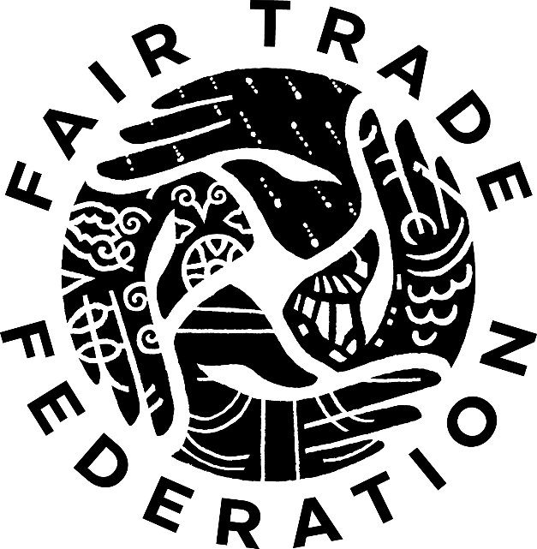

**Membership Application**

Café Network

FTF Membership Manager contact information:

screening@fairtradefederation.org

302.655.5024

**Prepare for Screening**

*Before spending time on the application, read the* [*Fair Trade Federation Code of Practice*](http://www.fairtradefederation.org/fair-trade-federation-code-of-practice/) *to become familiarized with eligibility and sourcing requirements and the nine fair trade principles.* Applying to the Fair Trade Federation (FTF) is a rigorous self-reporting process during which applicant businesses must demonstrate outstanding work in all nine of the fair trade principles. A high level of transparency and detail is required on the FTF Membership Application. The onus is on applicants to demonstrate due diligence in ensuring fair trade partnerships.

*The FTF Membership Manager acts as liaison to the FTF Screening Committee and guides applicants through the screening process.* The FTF Membership Manager reviews submissions for missing components and information. Applicants will receive follow-up questions to clarify information before an application is reviewed by an FTF Screening Committee. It takes approximately 2 to 4 months from the time all components of the application are submitted to receipt of a final membership decision. However, no amount of time is guaranteed.

*Application materials are confidential.* By submitting application materials, the applicant affirms all information provided is true and presents business practices for review by FTF Screening Committee members and FTF employees. The applicant acquiesces to the FTF Screening Committee’s decision about FTF membership. The applicant maintains the right to appeal the decision through established procedures.

**Application Checklist**

Submit application materials to screening@fairtradefederation.org. All application components may be submitted separately and at different times, as reasonable. Where possible, please submit documents in pdf file formats.

**Narrative Questions** – Please send this document electronically.

**Financial Statement** - Please submit a profit & loss statement for your business’s most recent fiscal year. It may be unaudited.

**Supplier List -** Please include a complete list of your organization’s wholesale suppliers. Include any affiliation a supplier may have with a fair trade business (e.g. membership in FTF, World Fair Trade Organization, Fair Trade Forum India, etc). For all suppliers that are not FTF or World Fair Trade Organization members, please include direct contact information.

**References** – Each individual who agrees to serve as a reference must fill out a general reference form (download form [here](http://www.fairtradefederation.org/become-a-member/screening-process/references/)) then submit it directly to the FTF. Applicants are responsible for contacting three general references and ensuring they submit the completed forms. References should not be employed by or currently volunteering for the applicant business. The FTF may contact individuals who submit a reference if additional information is needed.

**$85 (USD) Screening Fee** - Please mail a check payable to Fair Trade Federation or pay with a credit card [here](http://www.fairtradefederation.org/make-a-payment/). The screening fee is not refundable.

**Supporting Documentation** – Applicants are encouraged to submit documentation illustrating fair trade practices or other information about the business (e.g. cost analyses, contracts, impact assessments, contracts, continued improvement plans, news articles, product tags, annual reports, photos, etc.). Electronic submission is strongly preferred. Any physical items mailed to the FTF office will not be returned.

**Thank you for applying; we look forward to learning about your work.**

**Section 1: Business Information**

Registered legal name of business:

Public name of business:

Business website:

Contact person for this application:

Phone:

Email:

Business address:

City:

State/Province:

Postal Code:       Country:

Mailing address:  same as address above

Street address:

City:

State/Province:

Postal Code:       Country:

Preferred *public* telephone:

Preferred telephone for FTF contact:

Preferred *public* e-mail:

Preferred e-mail for FTF contact:

Please provide mailing addresses for all permanent physical retail spaces (if different from the address provided above).

1. How did your business learn about the Fair Trade Federation?

1. Does your business purchase products via

direct relationships with farmers/producers

wholesale suppliers

Comments:

1. Does your business report sales to a taxing authority in Canada or the USA?

Yes  No

* 1. If no, explain why not.

1. How long has your business been in operation?

1. How much did your business earn in gross sales of merchandise (in USD) during the last fiscal year?

1. When is your business’s fiscal year?

1. What is the legal standing of your Canadian/USA business?

For-profit corporation

Non-profit corporation

Sole Proprietorship

Cooperative

Other:

1. Describe the structure and staffing of your business. Include the number of employees/volunteers and their roles and responsibilities.

1. If your business is a trading branch within another business, describe their relationship.

**Section 2: Vetting Suppliers**

1. Indicate which items are ***sold*** in your business:

Clothing

Gift items (candles, baskets, cards, etc.)

educational products (e.g. books, music, maps, etc.)

products from local or small-scale producers in the USA, Canada, or Europe

environmentally friendly products

any other products that do not follow fair trade principles

Coffee

Tea

Wine/Beer/Liquor

Chocolate

Pastries/Baked goods

Packaged food

Sandwiches

Soups

Salads

Fresh/dried fruit

Other:

1. Indicate which items are ***used*** in your business:

Aprons

Flowers

Reusable napkins

Table linens

Dinnerware (bowls, plates, cutlery, etc.)

Tea accessories

Shirts/Uniforms

Soaps/Spa Products

Other:

1. What does your business look for when searching for potential wholesale suppliers? Use examples from your business’s supplier relationships and, wherever possible, relate them to the nine fair trade principles.

1. If your business uses FTF or WFTO membership as a tool for vetting suppliers’ fair trade practices, how are memberships confirmed?

1. How often does your business confirm suppliers’ memberships are up-to-date?

1. What does your business expect from suppliers that are not FTF or WFTO members?
2. What would cause your business to decline to purchase from a potential wholesale supplier?

1. Does your business have a formal process or questionnaire for evaluating wholesale suppliers?

Yes  No

* 1. If yes, submit a copy and provide any comments here:

**Section 4: Your Business in the USA or Canada**

**4.1 Creating Opportunity for Socially and Economically Marginalized Producers**

1. If your business has a mission statement, provide it here.

1. Why does your business choose to operate using fair trade practices?

1. Why does your business want to be a member of the Fair Trade Federation?

1. In which areas related to the fair trade principles does your business excel and why?

1. In which areas related to the fair trade principles is your business most challenged and why?

**4.2 Promote Fair Trade**

1. Provide examples of ways in which your business partners with other groups, companies, or individuals in the local community.

1. Describe the public education and advocacy activities your business participated in over the last year. If possible, provide a list of recent public events.

1. Describe future plans for similar activities.

1. How does your business collect information about the farmers/producers who grow/harvest the products sold?
2. What methods does your business you use to share this information with your community?

1. How does your business share information about *fair trade* with your customers?

**4.3 Develop Transparent and Accountable Relationships**

1. How often do you communicate with your suppliers?

1. What information about your business do you share with suppliers?

1. If you have ever stopped ordering from a supplier, please describe why.

1. In the past year, have you engaged in any disagreements with suppliers regarding payment?

Yes  No

* 1. If yes, please explain the situation and how it was resolved.

1. *If your business has a contract or agreement with your suppliers*, please describe in detail what the contract/agreement includes. Alternatively, submit a copy of the contract/agreement.

1. Include the ways in which suppliers offer their own input on the contract/agreement.

1. Have employees/volunteers visited any of the people who grow/harvest the products you sell?

Yes  No

* 1. If yes, describe. If no, does your business have plans to visit in future?

**4.4 Cultivate Environmental Stewardship**

1. How does your business impact the health of the natural environment in your Canadian/American community?

1. How does your business incorporate sustainability into its facilities and operations?

1. What challenges to a healthy natural environment are identified in your business’s operations and how are they addressed?

1. Does your business incorporate recycling, reuse, and post-consumer recycled supplies into its operations?

Yes  No

* 1. If yes, describe. If no, explain.

1. Does your business currently participate in a green certification program?

Yes  No

* 1. If yes, describe.

**4.5 Support Safe and Empowering Working Conditions**

1. Describe how your business’s employees/volunteers participate in decision-making.

1. Describe opportunities your business offers for employee/volunteer advancement and growth.

1. Describe or provide photos of where employees/volunteers work.

1. Describe how your business ensures a healthy and safe workplace for employees/volunteers.

1. Describe established procedures for all staff to securely address concerns and grievances.

1. Does your business have a written non-discrimination policy?

Yes  No

* 1. If no, why not?

* 1. If yes, how is this shared with employees/volunteers?

**4.6 Build Capacity**

1. What market data, product feedback, or other information does your business share with wholesale suppliers?

1. What information about your business is shared with other current and potential fair trade businesses?

1. What goals related to continued improvement of fair trade practices would your business like to achieve in the next five years?

**4.7 Respect Cultural Identity**

1. How does your business learn about and share information on the traditions and cultures of the people growing/harvesting the goods sold?

**4.8 Pay Promptly and Fairly**

1. When does your business pay wholesale suppliers?

**4.9 Ensure the Rights of Children**

1. Does your business purchase from any wholesale suppliers who work with individuals younger than age eighteen?

Yes  No

* 1. If yes, explain why your business decided to purchase from these wholesale suppliers.

1. Does your business employ anyone under the age of eighteen in Canada/USA?

Yes  No

* 1. If yes, explain how your business meets national, state/province, and local laws regarding the rights of children.

**Section 5: Additional Comments**